**P235/1**

**ISLAMIC RELIGIOUS**

**EDUCATION**

**(The Holy Qur’an)**

Paper 1

Jul/Aug 2019

2 ½ Hours

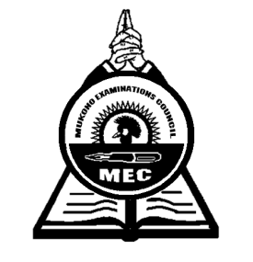

**MUKONO EXAMINATION COUNCIL**

**Uganda Advanced Certificate of Education**

**ISLAMIC RELIGIOUS EDUCATION**

**(The Holy Quar’an)**

Paper 1

2 Hours 30 Minutes

**INSTRUCTIONS TO CANDIDATES**

*Answer* ***four*** *questions in all.*

*All questions carry equal marks.*

*Any additional questions will not be marked.*

1. Account for the relevance of the Quran in bits.
2. Justify the view that the Quran is a divine base.
3. a) Examine the Qur’anic account of the people who were punished for disobeying him.

b) What verses do Muslims learn from the above punishment?

1. Explain the Qur’anic teaching on;

a) Predestination

b) Free work.

1. Explain the Islamic teachings on racism and slavery. ***(25 marks)***
2. Justify the view that Women were liberated by Islam. ***(25 marks)***
3. a) Explain he problems expected in Zakat distribution in Uganda.

b) Suggest measures to solve the above problems.

1. Examine the Islamic teachings on business transactions.
2. Explain the obligation of the led in the Islamic political system.
3. Examine the Quranic teachings on Jihad.
4. a) Analyze the content of Surat Al- Dhuha.

b) What lessons can be derived from the above Sulah?

1. a) Explain the measuring of Sulah Al- Asir.

b) How can the above Sulah influence in the bahaviour of a Muslim?

* ***End -***